Global Environmental Challenges
COP15 Challenge of Loss of Biodiversity
Responding in Southern Ontario and Worldwide

Date: Wednesday December 7th, 2022
Time: 14:00 to 16:00
Cost: Free
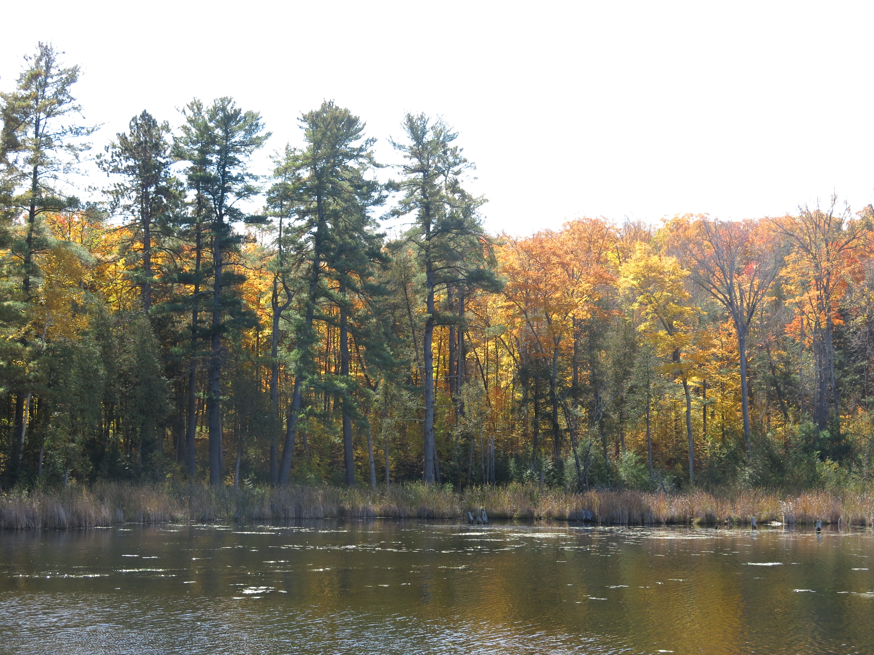
Moderator: Joseph Anawati, Canadian Institute of Forestry

Speakers and Agenda
1. An Urban Commitment to Biodiversity Conservation; the City of Mississauga Story

Andrew Puchalski, Mississauga Project Leader, Woodlands

Glen Prevost, Eastern Ontario Model Forest FSC Program Coordinator

2. Land Trusts: putting the power to permanently conserve land in the hands of the community

Calder Schweitzer, Executive Director, Thousand Islands Watershed Land Trust

3. Protecting the biodiversity of Ontario’s Lakes and Rivers and Adjacent Woodlands

Terry Rees, Executive Director Federation of Ontario Cottagers’ Associations (FOCA);

4. Addressing the twin crises of biodiversity loss and climate change through the International Model Forest Network

Richard Verbisky, Head of the International Model Forest Network Secretariat, Canadian Forest Service, Natural Resources Canada

